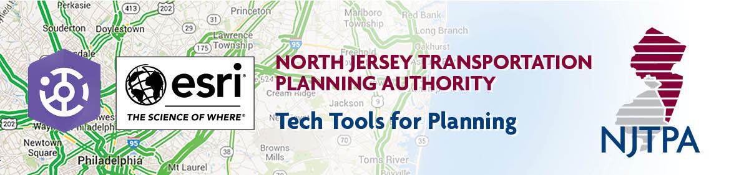
Agenda
Virtual Meeting
May 28, 2020
9:30am to 11:30am
- Introduction
- ArcGIS Hub- Conceptual Overview of Hub and Initiatives
  - Presentation:
    - Hub concept & ArcGIS Hub platform
    - How does Hub fit into the ArcGIS Platform?
    - What is an initiative?
  - Q/A
- NJTPA Initiatives and Tools
  - Presentation:
    - Open Data Portal
    - Local Concept Development
    - Goods Movement Strategies for Communities
  - Q/A
- Wrap-Up/Adjournment

