SOLICITATION FOR APPLICATIONS TO

**2021**

**LOCAL MOBILITY INITIATIVES PROGRAM**

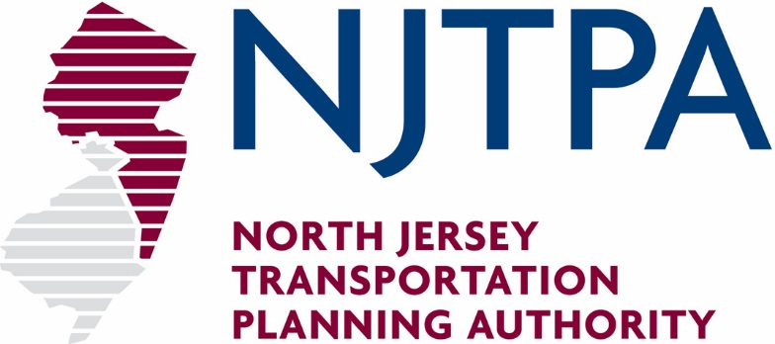

**Issued: February 2020**

**CONTENTS**

**Program Solicitation Overview** 1

**Thumbnail Requirements** 4

**Proposal Guidance and Instructions** 6

**NJTPA 2021 LOCAL MOBILITY INITIATIVES**

### **Program Solicitation Overview**

**Thumbnail sketches are due to the NJTPA by March 25, 2020. There will be an information session for all potential applicants at the NJTPA offices on March 12, 2020 at 10 a.m. Successful thumbnail sponsors will then be invited by the NJTPA to submit full proposals, which will be due on May 13, 2020 at 4 p.m.**

**INTRODUCTION**

Congestion Mitigation and Air Quality **(**CMAQ) funds have been allocated to the North Jersey Transportation Planning Authority (NJTPA) metropolitan area for projects that contribute to the attainment of the Clean Air Act standards by reducing emissions and congestion in the non-attainment and maintenance areas. The FY 2021 Transportation Improvement Program (TIP) for the NJTPA region has set aside funding for a competitive CMAQ program to fund eligible projects and services that demonstrate potential actions to achieve these air quality goals. Candidate projects will be evaluated, selected, and approved for funding by the NJTPA Board of Trustees, based on the program criteria described in this document. Approved projects will be submitted to the Federal Transit Administration (FTA) for federal authorization of funds.

**PROGRAM PURPOSE**

The NJTPA is soliciting applications for its **Local Mobility Initiatives** program, to be supported by federal CMAQ funds allocated to the NJTPA region. The purpose of this competitive program is to advance readily implementable and innovative transit shuttle services that improve air quality and reduce congestion in the NJTPA’s air quality maintenance and non-attainment areas.

A separate, but related, program supports **Transportation Clean Air Measures** that will reduce pollutant emissions and congestion in the NJTPA region. Applicants may apply to the two programs separately.

This document details the application process and program guidelines for the submittal of thumbnails and full proposals to the NJTPA **Local Mobility Initiatives** program.

**ELIGIBLE ACTIVITES**

Eligible activities are limited to shuttle services. The program will offer both operating and capital support for shuttle services as detailed below.

Operational Support is available for new and expanded shuttle services as a reimbursement program for costs associated with shuttle operations. These funds may be used for three or up to five years. Applicants are permitted to spread the third-year amount (an amount not to exceed the greater of year one or two) across an additional two years (i.e. years four and five). This approach provides for a taper-down period where the service transitions from federal funds to other public or private sources. *The program requires a 25 percent local match for shuttle operations.*

Vehicle Replacement is also available as capital support for existing and expanding services. Applicants may request funding to replace vehicles for existing successful services with new vehicles procured by NJ TRANSIT (in configurations shown on pages 16-17). Importantly, recipients of new vehicles may not reduce existing service through the useful life of the vehicle. *There is no local match required for vehicle replacement.*

Shuttle services supported by this program (through operational support and/or capital equipment) must be intended to develop financially sustainable and innovative services, reduce single occupancy vehicle trips and congestion, improve air quality, encourage and increase transit use, optimize the performance of local and regional transportation networks, connect to major transit routes (including with last mile connections to major destinations), and improve personal mobility. Applicants are encouraged to adopt best practices and innovations in services to lower costs, improve customer satisfaction, utilize alternative energy sources, ensure financial sustainability, and reduce air pollution. Proposals may not duplicate existing publicly funded transit services.

Proposed projects must be eligible under the federal CMAQ guidelines (page 12), be ready to implement, demonstrate the potential for reductions in emissions and congestion, and meet or exceed the requirements for matching funds.

Proposals must link to needs identified in the long-range transportation plan, *Plan 2045: Connecting North Jersey*. Possible projects can draw from a variety of sources, such as local and regional plans and projects, the Together North Jersey (TNJ) Plan, or the NJTPA’s Coordinated Human Services Transportation Plan or Subregional Studies Program reports. Links to guidance documents and resources are provided on page 12.

**TIME FRAME**

The solicitation for Local Mobility Initiatives provides funds for three operating years that may be used for up to five years from the commencement of operations. Applicants are permitted to spread the third-year amount (an amount not to exceed the greater of year one or two) across an additional two years.

**ELIGIBLE ENTITIES**

Eligible applicants for Local Mobility Initiatives funding include Transportation Management Associations (TMAs), municipalities, and county transportation system operators in the NJTPA region.

**HOW TO APPLY**

The Local Mobility Initiatives Program application is a two-step process that begins with the submission of thumbnail sketches. The NJTPA will review thumbnail sketches and successful eligible submissions will be invited to submit full proposals.

An information session will be held on **March 12, 2020 at 10 a.m.** at the NJTPA offices at One Newark Center, 17th Floor, Newark, NJ 07102. Attendance at the information session is strongly encouraged.

Thumbnail Review

Applicants interested in submitting proposals for the Local Mobility Initiatives Program must submit thumbnails in accordance with the applicable category requirements found on page 4 of this document. Applicants may submit multiple thumbnails and should rank their applications in order of priority. In preparing thumbnails, applicants should also review the full proposal guidelines and review criteria. Thumbnail sketches are due on **March 25, 2020.**

The NJTPA will review all thumbnails to determine eligibility under CMAQ and to identify the most promising and implementable projects. Thumbnails will also be evaluated for opportunities for improvement and constructive suggestions will be offered to sponsors as appropriate. Applicants will be notified of the thumbnail review results and may be invited to submit full proposals in **April 2020**.

Full Proposals

Full proposals will be due on **May 13, 2020 at 4 p.m.** TMA and municipal applicants invited to submit full proposals must include letters of support from the NJTPA Regional Transportation Advisory Committee (RTAC) member from their county or city, or another appropriate county or city representative. A current list of RTAC members is available on the NJTPA website.

A Technical Review Committee will evaluate full proposals based on identified criteria. Recommendations from the Technical Review Committee will be presented to the NJTPA Project Prioritization Committee and Planning and Economic Development Committee for endorsement and then to the NJTPA Board of Trustees for approval. Approved projects will be submitted to the FTA for federal authorization of funds.

Inquiries

Questions about the solicitation **must be submitted in writing** by email to the attention of Peter Bilton at [pbilton@njtpa.org](mailto:pbilton@njtpa.org). Inquiries should reference **“Solicitation for Applications to the 2021 Local Mobility Initiatives Program.”** Copies of all questions, and any replies, will be made available on the NJTPA website: <http://njtpa.org/Projects-Programs/Local-Programs/CMAQ-Local-Mobility.aspx>

The deadline for inquiries is **March 16, 2020 at 4 p.m.** Late inquiries may not be reviewed or considered.

**NJTPA 2021**

**LOCAL MOBILITY INITIATIVES PROGRAM**

### **Thumbnail Requirements**

Identify a specific shuttle project (Operational Support or Vehicle Replacement) that can be readily implemented to measurably reduce pollutants and congestion eligible under the Federal Congestion Mitigation & Air Quality (CMAQ) program.

**Project Sponsor(s):** *Identify the sponsor organization. List any partner agencies and organizations.*

**Project Name:**  *Designate a project name.*

**Project Rank:** *Only if submitting more than one proposal, indicate project rank (first, second, third).*

**Estimated Funding**

**Amount Requested:** *For operational support only, estimate federal funding request. Funding for operations requires a 25% local match. Vehicle replacement does not require a match.*

**Funding Type:** *Indicate whether proposal is for operational support or vehicle replacement. Applications for existing service expansions proposed in addition to vehicle replacement are required to submit separate applications.*

**Description:** *Describe the project or service and how it will be implemented. For vehicle replacement, describe the existing service.*

**Project Identification:** *How was the need for this service, whether proposed or expansion of existing service, identified? Sources should include at least one of the following: recommendations from a federal, state or local plan; Plan 2045; TNJ Plan; locally developed coordinated human services transportation plan (CHSTP); or other quantifiable need.*

**Estimated Benefits:** *Identify estimated emissions and congestion benefits. Include secondary benefits to neighboring communities.*

**Location:** *Indicate the location of the project and describe where the estimated emissions and/or congestion reductions will occur. Include a map with the following: the route or route area, other publicly funded routes, and significant origins and destinations. The location map for a proposed operational support project does not need to indicate a specific route but should indicate the general area and the major origins and destinations.*

***Routes that duplicate existing publicly funded transit services are ineligible for support under this program****.*

**Contact Person:** *Provide the name, phone, number, and email address of the primary point of contact at the sponsor.*

**Thumbnail Submission:** *Submit applications to:*

Peter Bilton

Principal Planner, TMA and Mobility Programs

North Jersey Transportation Planning Authority

One Newark Center, 17th Floor

Newark, NJ 07102

[pbilton@njtpa.org](mailto:jperlman@njtpa.org)

973-639-8450

**This thumbnail should be a maximum of two pages, not inclusive of the map.**

**NJTPA 2021**

**LOCAL MOBILITY INITIATIVES**

### **Proposal Guidance and Instructions**

This section provides detailed guidance on submitting a full proposal for the **Local Mobility Initiatives** **Program.** Full proposals are to be prepared upon invitation by the NJTPA following successful submission and review of a thumbnail sketch as described in the Program Solicitation Overview section (starting on page 1) and organized as described on page 4.

Eligibility

Eligible activities are limited to shuttle services as described in the Solicitation Overview section of this document. The program offers both operational support and vehicle replacement. Proposals that duplicate existing publicly funded transit service are ineligible for funding.

Eligible applicants and matching fund requirements are described in the Solicitation Overview section. Eligible applicants are TMAs, municipalities, and county transportation system operators in the NJTPA region. TMA and municipal applicants must include letters of support from the NJTPA Regional Transportation Advisory Committee (RTAC) member from their county or city, or another appropriate county representative. Matching funds of 25 percent required for operational support must come from local sources other than federal transportation funds or NJ TRANSIT operating funds. A letter of commitment from the provider of the matching funds is required.

Recipients of operating assistance must comply with FTA requirements related to the contracting of services. More information is available on the FTA website (<http://www.fta.dot.gov/legislation_law/12349_8641.html>). This includes but is not limited to a Title VI plan and FTA drug and alcohol testing. Additionally, all services must be open to the general public, and comply with the Americans with Disabilities Act (ADA).

Innovation in Operations

Innovations in operations are encouraged under this guidance and are considered in the selection criteria. These include but are not limited to the implementation or deployment of:

* Low carbon fuel vehicles
* Vehicle noise reduction
* Vehicle idle reduction
* Other innovations that increase ridership, passenger information and satisfaction, and reduce air pollution

Americans with Disabilities Act (ADA) Requirements

Transit services, including but not limited to shuttles, must comply with the Americans with Disabilities Act. These requirements include, but are not limited to, the use of wheelchair lift-equipped, accessible vehicles and offering deviated fixed route services.

Title VI Requirements

The NJTPA in accordance with the provisions of Title VI of the Civil Rights Act of 1964 (78 Stat. 252, 42 US.C.§§ 2000d to 2000d-4) and the Regulations, hereby notifies all interested parties that it will affirmatively ensure that for any contract entered into pursuant to this solicitation, disadvantaged parties will be afforded full and fair opportunity to submit thumbnail sketches and proposals in response to this invitation and will not be discriminated against on the grounds of race, color, or national origin in consideration for an award. For reference, please see NJTPA’s Title VI Plan (<http://www.njtpa.org/NJTPA/media/Documents/About-NJTPA/Federal-Regulations/Title-VI/Title_VI_Implementation_Plan.pdf>). The NJTPA also encourages proposals that have sought out and considered the needs of those traditionally underserved by existing transportation systems, including, but not limited to, low income and minority households.

**PROPOSAL REQUIREMENTS**

In order to be considered for funding, proposals for operating assistance and vehicle replacement must meet several requirements, outlined below. These requirements may also be included as part of the selection criterion.

The application must demonstrate need in one of the following ways (operational support and vehicle replacement):

* + Problem identification linked to needs, strategies, and related projects in *Plan 2045.*
  + Proposal or service fulfills a need identified in an NJTPA, TNJ, NJ TRANSIT, New Jersey Department of Transportation, Port Authority of New York and New Jersey, or other related agency sponsored study.
  + Proposal or service fulfills a need identified in a county or municipal master plan or study.
  + Proposal or service complements a planned transit or roadway capacity increase.
  + Proposal or service seeks out and considers the needs of those traditionally underserved by existing transportation systems, including but not limited to low income and minority households.
  + Proposal or service fulfills another need not included in the above designated areas but is well documented in the application.

The application must demonstrate a potential for success after the CMAQ funding period has ended (operational support only). Items that are required for consideration are:

* + Description of potential for financial sustainability of the project without further federal funding. This may include letters of support or commitment from public or private sector financial sponsors. If letters of support or commitment are not available, present a plan for attracting and retaining ongoing financial support.
  + Description of marketing and communication activities that the sponsor and its partners will undertake to attract or maintain ridership. Note that marketing costs must be borne by the applicant.

The application must provide specific information related to service operations (operational support and vehicle replacement). This includes:

* + Comprehensive budget (operations only)
  + Quantifiable benefits for congestion mitigation and improved air quality (via the included spreadsheet and formula)
  + For operational support, provide a map and description of planned routes and/or service area and other transit services and facilities. For vehicle replacement, provide a map and description of existing service (including ridership information and schedule) for route(s) to be serviced with the replacement vehicle.
  + Vehicle inventory using provided template, for all vehicles operated by the sponsor (vehicle replacement only)

The application must provide specific information related to the use of pollution reduction strategies (operational support and vehicle replacement). This may include but is not limited to:

* + Low-carbon fuels
  + Anti-idling measures
  + Driver performance monitoring
  + Advanced emissions reduction equipment

**SELECTION CRITERIA**

Proposals will be reviewed and scored by a technical review committee consisting of NJTPA Central Staff and NJ TRANSIT staff using the following criteria:

* **Demonstration of Need (Operations & Vehicle Replacement) 25 points**
  + Proposal demonstrates a strong link to a well-defined and documented need. Additional consideration will be given to proposals that address the needs of those traditionally underserved by existing transportation systems including but not limited to low income and minority households.
* **Potential for Success (Operations Only) 25 Points**
  + Proposal addresses a transportation demand and projected ridership is well reasoned and strong.
  + Proposal seeks to offset significant single occupancy vehicle trips.
  + Regional impacts of the proposed service are clearly demonstrated.
  + Proposal demonstrates the ability to provide a usable connection to transit.
  + Proposal describes marketing and communications activities to attract and retain ridership.
  + Proposal includes a service sustainability plan to attract and retain private or local public financial support.
* **Demonstrated Success (Vehicle Replacement Only) 25 Points**
  + Complete details of existing service are provided.
  + Service addresses a transportation demand, demonstrated by strong ridership.
  + Service currently offsets significant single occupancy vehicle trips.
  + Regional impacts of the service are clearly demonstrated.
  + Service provides a usable connection to transit.
  + Marketing and communications activities to attract and retain ridership.
  + Service sustainability plan to attract and retain private or local public financial support.
* **Operations (Operations and Vehicle Replacement) 35 Points**
  + Accuracy and clarity of budget.
  + Support for, and integration with, the existing public transit network, without duplication of the existing public transit network.
  + Ability to implement the service in a timely manner.
  + Quantifiable benefits for congestion mitigation and improved air quality.
  + Staffing capabilities.
  + Successful record of implementing shared ride services.
* **Innovation (Operations and Vehicle Replacement) 15 Points**
  + Utilization of low carbon fuel sources.
  + Implementation of enhanced customer satisfaction measures.
  + Measures to increase service attractiveness.
  + Implementation of cost reduction tactics.
  + Implementation of other innovations that increase ridership, passenger information and satisfaction, and reduce air pollution.
  + Other innovations that advance the goals of the program.

**PROPOSAL CONTENTS**

1. **Demonstration of Need (Operations and Vehicle Replacement)**
   1. Cite the plan, study, or other source that identifies the need being fulfilled. Quote appropriate sections of source material in the application. Identify the needs of disadvantaged populations including but not limited to low income and minority households.
   2. Describe how the proposed or existing service will fulfill or is fulfilling the need identified in item 1.1. Applicants are encouraged to supplement the description with graphics, maps, and statistics, as necessary.
2. **Potential for Success (Operations Only)**
   1. Describe the existing transportation demand and projected ridership, and the sources and methods used to make that determination.
   2. Describe the typical trip replaced by the proposed service.
   3. Describe the regional impacts of the services proposed.
   4. Describe how the service will provide transportation benefits to, or alleviate transportation burden on, disadvantaged populations including but not limited to low income and minority households .
   5. Describe the potential for this service to provide a usable connection to transit.
   6. Describe the marketing and communications approach proposed to attract and retain riders.
   7. Describe the plan to attract and retain private and local public financial support to extend the service beyond its proposed CMAQ funding.
3. **Demonstrated Success (Vehicle Replacement Only)**
   1. Provide ridership counts for at least the last five years of service.
   2. Describe the typical trip replaced by the service.
   3. Describe the regional impacts of the services provided.
   4. Describe how the service provides transportation benefits to, or alleviates transportation burden on, disadvantaged populations including but not limited to low income and minority households.
   5. Describe how the service provides a useful and usable connection to transit.
   6. Describe the marketing and communications plan proposed to attract and retain riders.
   7. Describe the plan to attract and retain private and local public financial support for providing for continued operations and capital replacement.
   8. Provide a vehicle inventory using the vehicle inventory template provided, for all vehicles operated by the sponsor. Provide a list of vehicles proposed for replacement (see page 16-17 reference).
4. **Operations (Operations and Vehicle Replacement)**
   1. Describe the proposed or existing service: routes, scheduling, hours of service, vehicle(s) to be used, and anticipated fares (if any).
   2. Describe the plan to implement services in a timely manner after funds are made available. (Operations Only)
   3. Describe the system that will be or is being used for dispatching, scheduling, recording, and analyzing ridership data.
   4. Demonstrate air quality benefits of a proposed or existing service using the EPA’s formula for emissions reduction. Include information about how the formula inputs were determined. See page 14 for a completed example, and the NJTPA website for a functional spreadsheet: <http://njtpa.org/Projects-Programs/Local-Programs/CMAQ-Local-Mobility.aspx>
   5. List all appropriate staff, their relevant experience, and their role in the proposed project.
   6. Provide a listing and summary of transportation programs operated that demonstrate successful implementation and operations of services.
5. **Budget (Operations Only)**
   1. Provide a detailed budget, including the 25% local match, using the budget template provided or equivalent (see page 15).
   2. Provide an estimate of cost per hour of service and cost per ride.
6. **Innovation (Operations Only)**
   1. Describe any planned or existing innovations in shuttle services this proposal will support, including any expected costs and gains. For example, using alternative fuels is expected to cost $*x*/gallon, for *y* gallons per year, and save *z* units of criteria air pollution. A list of suggested innovation strategies is included in the program guidance.
7. **Subregional and Local Support (Operations and Vehicle Replacement)**
   1. Include a letter of support for TMA and municipal proposals from the NJTPA Regional Transportation Advisory Committee (RTAC) member from their county, or another appropriate county representative.
   2. Include copies of letters of commitment from the provider(s) of the matching funds for all proposals.
   3. Include letters of support from local businesses and government (optional).

**GUIDANCE DOCUMENTS AND RESOURCES**

Congestion Mitigation and Air Quality Program Provisions

Proposals will be reviewed for compliance with FHWA CMAQ Program Policies and Guidance.

<https://www.fhwa.dot.gov/environment/air_quality/cmaq/>

Plan 2045

The NJTPA’s Regional Transportation Plan, *Plan 2045: Connecting North Jersey,* is the guiding document for transportation investment policy for the northern New Jersey region.

<http://njtpa.org/Planning/Plans-Guidance/Plan-2045.aspx>

Together North Jersey

Since 2012, the NJTPA, NJ TRANSIT, the Alan M. Voorhees Transportation Center at Rutgers University, the New Jersey Office for Planning Advocacy, NJTPA subregions and core cities, and a variety of other public, institutional, and nonprofit entities have worked together on the development and advancement of the Together North Jersey Plan. The outcome of plan implementation will be a more sustainable future for the region that invests in existing communities where housing, jobs, educational, cultural, and recreational opportunities are accessible to most residents of the region without having to drive. <https://togethernorthjersey.com/>.

Subregional Support

Proposals from TMAs and municipalities must be supported by an NJTPA member subregion. This most often comes from a subregional representative to the NJTPA’s Regional Technical Advisory Committee (RTAC). The RTAC provides a forum for presentation and discussion on regional issues. It also performs a vital function in reviewing and disseminating information and making recommendations to the NJTPA Board and its individual Trustees to aid in decision-making.

<http://njtpa.org/About-NJTPA/Who-We-Are/Committees/Regional-Transportation-Advisory-Committee.aspx>

Templates/References

The resources on pages 14 to 17 offer standardized formats for estimating emissions benefits, expenditure reporting, and vehicle replacement descriptions. Electronic versions of these documents, as well as the vehicle inventory template, are available for download.

<http://njtpa.org/Projects-Programs/Local-Programs/CMAQ-Local-Mobility.aspx>

**HOW TO APPLY**

Full proposals are due to the NJTPA at **4 p.m. on** **May 13, 2020.** Electronic copies of the written application and attachments, provided as original document and spreadsheet files, must be submitted. Eligibility requirements are listed in the Program Solicitation Overview (pages 1-3) and the Proposal Guidance section.

The electronic versions of the air quality and financial spreadsheets are available on the web at:

<http://njtpa.org/Projects-Programs/Local-Programs/CMAQ-Local-Mobility.aspx>

A Technical Review Committee consisting of staff from NJTPA and NJ TRANSIT will review all proposals based on the criteria listed on pages 8-9. Recommendations from the Technical Review Committee will be presented to the Planning and Economic Development Committee for endorsement and then to the NJTPA Board of Trustees for approval.

Upon approval by the NJTPA Board of Trustees, administration of the program is transferred to NJ TRANSIT under FTA CMAQ (Section 5307) and all agreements for operating service and vehicles are between NJ TRANSIT and the subrecipient.  Please note that vehicle delivery and/or operating agreements may take up to 18-24 months after NJTPA Board of Trustees approval. It is expected that services will commence within six months of receipt of the contract from NJ TRANSIT. Delayed commencement of service beyond this timeframe may result in the reallocation of resources or other actions.

Applications should be addressed to:

Peter Bilton

Principal Planner, TMA and Mobility Programs

North Jersey Transportation Planning Authority

One Newark Center, 17th Floor

Newark, NJ 07102

[pbilton@njtpa.org](mailto:Jperlman@njtpa.org)

(973) 639-8445

**ADMINISTRATION OF THE PROGRAM**

Funding for the selected projects is a reimbursement program. If a project is selected the sponsor will be required to submit regular reports to NJ TRANSIT and the NJTPA.

**EMISSIONS ESTIMATE GUIDANCE**



**BUDGET TEMPLATE**



**REPLACEMENT VEHICLE DESCRIPTIONS**

Vehicles are purchased by NJ TRANSIT through FTA compliment competitive vehicle procurement. Vehicles are titled to the subrecipient with NJ TRANSIT as first lien holder. NJ TRANSIT is responsible for all oversight of vehicles until Federal useful life is met.

All vehicles are gas or diesel engines with automatic transmissions, front & rear heat, front & rear air conditioning, with enclosed stepwells. Extended cutaways will be available with CNG conversions. Cutaways are equipped with passenger side lifts that can be front or rear lifts depending on your needs. For the most part the vehicles have fixed seats, but some plans can have either foldaway seats added provided there is room. All body on chassis vehicles or cutaways are dual rear wheel cutaways that can range in wheelbases from 158” to 208” with overall body lengths that can also range from 260” to 382”.

**Vehicle Types**

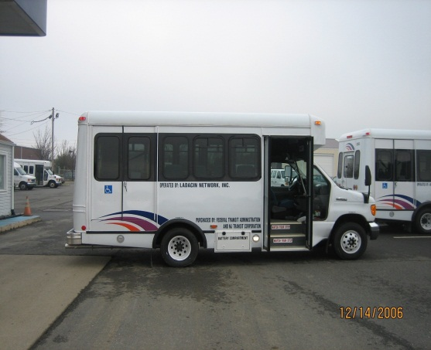 Small Cutaway Rear Lift

This vehicle can transport up to eight (8) ambulatory passengers and up to two (2) mobility devices. Useful Life is 5 years or 150,000 miles.

Standard Cutaway

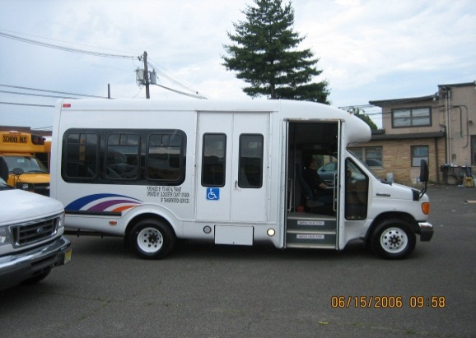

This vehicle can transport up to twelve (12) ambulatory passengers and a minimum of two (2) mobility devices. Useful Life is 5 years or 150,000 miles.

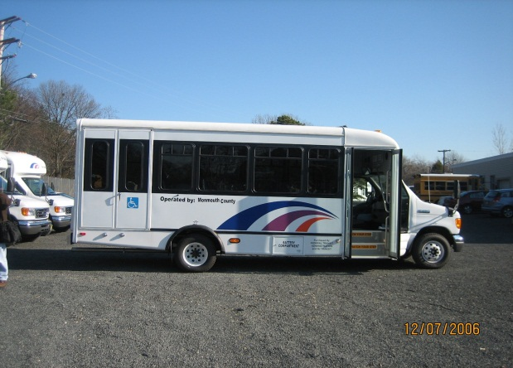Extended Cutaway

This vehicle can transport up to sixteen (16) ambulatory passengers and a minimum of two (2) mobility devices. Useful Life is 5 years or 150,000 miles.

Transit Style Bus

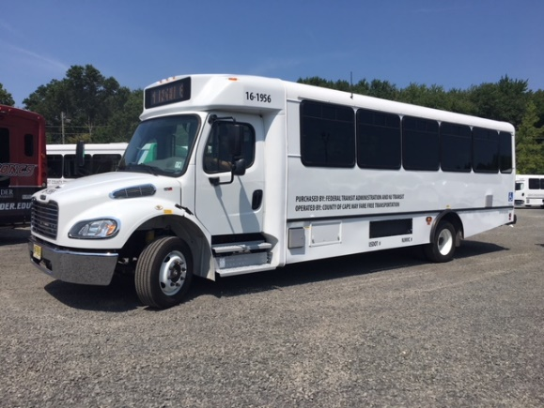

This vehicle is designed to transport between twenty-two (22) to twenty-four (24) ambulatory passengers and a minimum of two (2) mobility devices. Drivers are required to have a Commercial Drivers License (CDL) to operate this vehicle. Useful Life is seven (7) years or 200,000 miles.

Low Floor

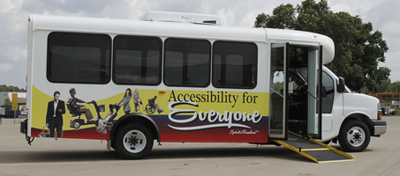

Low floor and CNG vehicles are available for both the standard and extended cutaways (seating configurations will vary).